

**INTERNSHIP REPORT**

**COMPUTER SCIENCE ENGINEERING**

**DIPLOMA 5th SEM**

**Subject Code- 1618509**

This report is being presented as part of CS Diploma 5th sem –

Subject Code 1618509 course to describe the details of

the internship work done at the technology company.

Prepared by – **Harsh Kumar**

[Board Roll - 511771816012]

**Patna Sahib Technical Campus**

**Bhagwanpur,Vaishali, Bihar 844114**

**PREFACE**

Telematics Service Systems is one of leading technology [Software developing, Hardware maintenance and Communication service provider] company in Bihar, India. They develop innovative and cost effective software and Communication services in both commercial and government sectors including BSNL, Indian Telephone Industry (ITI), Airtel Infocomm., Bharti Infratel, Deloitte Consulting LLP, ICSIL, Nortel, RHPL,Secure Search Screening private Limited and Reliance JIO. With the advent of modern technologies they also incorporate their customers with new application and ideas. They have well trained professional to develop software and Hardware services and meet the customer demand. Their unique approach to train and develop human resources to adapt to the market demands leads them to national as well as international market.

With the huge support of professional developers Telematics Service Systems is trying to emphasis the newer technologies like Mobile application development and many more. They have a lot of experience to work with rest of the software and Communication industry. They have developed many software solutions to the corporate leaders. And they have Served many Communication Company in the field of Repairing and Maintenance of Power Plants, AVR and DG sets.

**Table of Contents**

|  |  |  |
| --- | --- | --- |
| Sl No. | Contents | Page No. |
| 1 | **Chapter 1 (Background of the Report)** | 6 |
| 1.1 | * Background | 7 |
| 1.2 | * Objectives of the report | 7 |
| 1.2.1 | * Broad Objective | 7 |
| 1.2.2 | * Specific Objectives | 8 |
| 1.3 | * Scope of the Report | 8 |
| 1.4 | * Methodology | 8 |
| 1.4.1 | * Primary Sources | 8 |
| 1.4.2 | * Secondary Sources | 8 |
| 1.5 | * Limitations of the Report | 9 |
| 2 | **The Organization** | 10 |
| 2.1 | * An Overview of Telematics Service Systems | 11 |
| 2.2 | * Vision, Values and Mission | 11 |
| 2.2.1 | * Vision | 11 |
| 2.2.2 | * Values | 11 |
| 2.2.3 | * Mission | 11 |
| 2.3 | * Quality Management Framework (QMF) | 12 |
| 2.4 | * Who They Serve | 12 |
| 2.5 | * Business Area | 12 |
| 2.6 | * Industry Type | 13 |
| 2.7 | * Location | 13 |
| 2.8 | * Organization Structure | 13 |
| 2.9 | * Functional Domains | 14 |
| 2.9.1 | * Mobile Application Development | 14 |
| 2.9.2 | * Windows Software Development | 15 |
| 2.9.3 | * Web Development | 15 |
| 2.9.4 | * Web Application Development | 16 |
| 2.9.5 | * Power Plant Maintenance | 16 |
| 2.9.6 | * Telecommunication Audit | 17 |
| 2.9.7 | * Telecommunication Hardware Installation | 17 |
| 2.9.8 | * QA/Testing Services | 18 |
| 2.9.9 | * QA / Testing Consultancy | 18 |
| 2.9.10 | * Life at Telematics | 19 |
| 2.9.11 | * Telematics’s Popular Clients | 19 |
| 3 | **Chapter 3 (Intership Experience & Job Description)** | 20 |
| 3.1 | * Software development process of Telematics | 21 |
| 3.2 | * Software development activities | 21 |
| 3.2.1 | * Planning | 21 |
| 3.2.2 | * Implementation, testing and documenting | 22 |
| 3.2.3 | * Deployment and maintenance | 22 |
| 3.3 | * Software development models | 22 |
| 3.3.1 | * Waterfall model | 23 |
| 3.3.2 | * Code and fix | 23 |
| 3.4 | * Process improvement models | 24 |
| 3.4.1 | * Capability Maturity Model Integration | 24 |
| 3.4.2 | * ISO 9000 | 24 |
| 3.5 | * Formal methods | 24 |
| 3.5.1 | * Types of Team in a Software Firm | 24 |
| 3.5.2 | * Hierarchy of a Software Development Firm | 25 |
| 3.5.3 | * Overview of Scrum | 25 |
| 3.5.4 | * Backlog creation | 26 |
| 3.5.5 | * The Agile | 27 |
| 3.5.6 | * How Telematics supports agile software development | 28 |
| 4 | **Chapter 4 (Mobile Application Development)** | 29 |
| 4.1 | * Overview | 30 |
| 4.2 | * Steps of development | 30 |
| 4.3 | * Tips | 32 |
| 4.4 | * Motivation for Android | 33 |
| 4.5 | * Android Application Development | 33 |
| 5 | **Chapter 5 (Project Part)** | 34 |
| 5.1 | * Applications | 35 |
| 5.2 | * Panchatantra Ki Kahani | 35 |
| 5.3 | * BeShop: Compare prices and products | 36 |
| 5.4 | * Dragme IDE: Visual IDE for C language | 37 |
| 6 | **Chapter 6 (Marketing & Manpower)** | 39 |
| 6.1 | * Marketing & Marketing Details | 40 |
| 6.2 | * Man Power & its Management | 40 |
| 7 | **Chapter 7 (Overall Findings)** | 41 |
| 7.1 | * Future of the firm in India | 42 |
| 7.2 | * Current position and Prospective future of Telematics in India | 42 |
| 7.3 | * Recommendation | 43 |
| 7.4 | * Conclusion | 43 |



**1.1 Background**

I was lucky to get the opportunity to complete our industrial training at Telematics Service Systems. Since Telematics is a leading technology [software, Hardware maintenance and Communication service provider] company and developing software from a long ago in India we consider ourselves timely to get chance to take a deep look to their development methods, working models, deals and industrial behavior. We visited the head office 1, Shahu market, attardah, kachchi pakki road, Muzaffarpur, Bihar-842001 and Company Lab at Gulmohar Villa, road no 3, Majhaulia-Khabra, Muzaffarpur, Bihar-843146 almost every day from 02 July 2018 to 29 July 2018 in the Semester.

I intended to look into the software industry and how it looks like, what are their rules, responsibility and environment. Obviously they work with almost every platform and technologies. I worked with the part of Software Development team and generated new innovative ideas. Mainly I developed two android applications and one Integrate Development Environment for C language which run on the android devices and Windows computer simultaneously. While developing these software we tried to follow the coding conventions and user satisfaction criteria to maintain the quality of the software. Software quality assurance is one of the main challenges of the industry.

**1.2 Objectives of the Report**

The report has broad and specific objectives to follow.

**1.2.1 Broad Objective:**

Theoretical knowledge can never fulfill the knowledge of developing software. The industry has to maintain lot things to reach software to root level users. These workings and thinking can only be achieved by working with them.

**1.2.2 Specific Objectives:**

Besides the main or broad objective, the report has some specific objectives, which are given in the following:

* To know about the problems faced in the software industry
* To know how these problems are solved
* To know the coding style and conventions of the industry
* To go through the development cycle and models
* Working with documentation and customization
* Understanding software maintenance

**1.3 Scope of the Report**

This report has covered the direct and indirect aspects of software industry and their challenges. In addition, the report is focused on mobile application and Windows Software development. With the advancement of these software all over the world india is also trying to cope with that.

**1.4 Methodology**

For this report, information has been gathered from both primary and secondary sources.

**1.4.1 Primary Sources:**

For primary data, several face-to-face interviews have been conducted with officials from different departments of Telematics. Information provided by them has been very important for this report.

**1.4.2 Secondary Sources:**

To understand CMMI Level, software quality assurance, Agile method, Scrum data has been gathered from the internet and different articles and other sources.

**1.5 Limitations of the Report**

While gathering information, analyzing and representing them we have faced some limitations. However, despite the limitations we have tried hard to prepare a comprehensive and rather interesting report. The overall limitations of the report are mentioned below:

* Some statistical and qualitative data that were needed were not fully obtained. The Finance and Accounts officials, along with the Supply Chain officials were part of core team development. Because they were very busy, we had difficulties in meeting and gathering information from them.
* Because we were not full time inters at Telematics, we could not see the disadvantages of the old system ourselves.
* Because of organizational confidentiality, I could not put or disclose some information in the report.

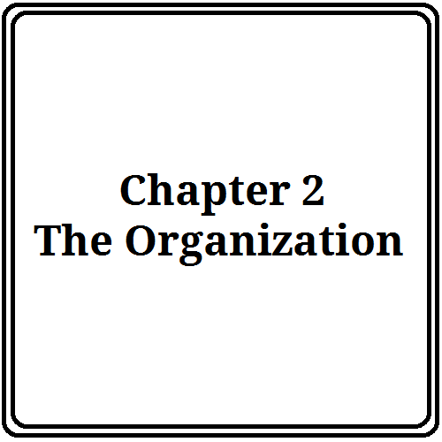

**2.1 An Overview of Telematics Service Systems**

Telematics Service Systems is a leading software, Hardware maintenance and Communication service provider company in India. Founded in 1998. Telematics Service Systems has successful track records for delivering most innovative and cost-effective technical services to customers in both commercial and Government sectors. Since its inception back in 1998, stepped into the core field of Communication Service providing to cater to the needs of enterprise, governance and economy. Strengthened by a strong team of experienced professionals Telematics Service Systems has a unique approach towards continuous training and development of human resources to adapt to the market demands for the national and international venues. Telematics Service Systems is incorporating new technology to further expand client base and continue to serve clients with a little more than utmost satisfaction.

**2.2 Vision, Values and Mission**

**2.2.1 Vision:**

Powered by innovation, guided by integrity, deliver quality solutions to build The Digital Delta.

**2.2.2 Values:**

* Customer Satisfaction is permanent to business success so they strive to exceed customer expectations.
* Telematics is result oriented so they seek continuous improvement through aggressive, attainable goals.
* They are committed to innovation because innovations can transform the way our customers do business.
* Great teams build great companies so they seek to attract, develop and retain leading talent.
* Telematics aspires to lead by setting the standards that others emulate.
* They are honest and fair in their dealings with customer, staff and each other.

**2.2.3 Mission:**

* To maintain the leading software solution provider ensuring benefit of customers, shareholders and employees
* Developing, disseminating and exploiting the remarkable experience, expertise and knowledge of all of our people
* Developing a distinctive competence in process development and project management

**2.3 Quality Management Framework (QMF):**

Telematics Quality Management focuses on following process areas:

1. Requirement Development

2. Technical Solution

3. Product Integration

4. Verification

5. Validation

6. Organizational Process Focus

7. Organizational Process Definition

8. Organizational Training

9. Integrated Project Management

10. Risk Management

11. Decision Analysis and Resolution

**2.4 Who They Serve**

Telematics has nearly twenty years’ experience developing, implementing customized solutions for organizations around the world, in many industries, in public and private sectors, from startups to multinational companies. Telematics customers include health care, engineering / construction firms & owner / operators, manufactures, utility & communication companies, development agencies and many more. Through their work Telematics customers make the world safer and more prosperous.

**2.5 Business Area**

* Wireless & Mobile Telecommunication
* E-Commerce
* Software Development
* Security
* Electricity Production & Distribution
* Information Management
* Internet Service Provider
* Portals
* Microelectronics & Technology
* Collaboration & Messaging
* Business Consulting
* Solution for Entertainment

**2.6 Industry Type**

Telematics mainly belongs to the following industries:

* Communication and Technology Industry
* Software Industry
* Hardware maintenance industry

**2.7 Location**

Telematics Service Systems is located at the following addresses:

* Headquarter : 1, Shahu market, attardah, kachchi pakki road, Muzaffarpur, Bihar, India -842001
* Hardware Laboratory : Gulmohar villa, Road no 3, Adarsh nagar, Majhaulia, Muzaffarpur, Bihar, India -843146

**2.8 Organization Structure**

Telematics is headed by Director. They have two departments. Both of the departments are headed by its own Department General manager.

A. Software Development Department B. Telecommunication Department

1. **Software Development Department**

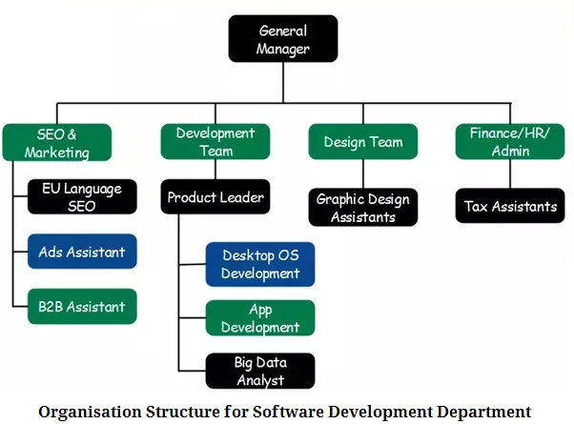

1. **Telecommunication Department**

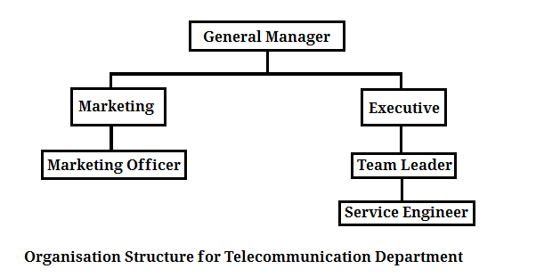

**2.9 Functional Domains**

**2.9.1 Mobile Application Development**

Telematics develops their software under name GrapeBits**. GrapeBits** is the mobile application development powerhouse. Telematics is planning to revolutionize the mobile industry with Continuous innovation. They have students, experienced developers, members from software programming, from communications, from creative arts & crafts and from a ton of other disciplines. They are trying to brand Bihar as the Global Leader in Mobile Development.

They develop mobile apps for Android, iOS, Windows phone and Tizen phone. They have expertise for any kind of mobile application development. Their apps are on the following markets:





logo.png

**2.9.2 Windows Software Development**

Telematics develops innovative windows software under name **GrapeBits**. They are trying to brand Bihar as the Global Leader in Mobile Development. Their apps are on the following markets:





freeware logo.jpg



**2.9.3 Web Development**

In today’s market website development plays a vital role for an organization. It is a onetime investment with huge returns. Web development solutions find its way in the implementation of business policies on the web by the use of data services. If you are looking for software consultant to develop your web application or website then Telematics is the stoppage for you as it provides practical and reliable advises for your business. Telematics is an expert in web development solutions. It provides services across the globe which is within the budget and is customer centric.

Telematics web development focusing areas are:

* Web Application Development
* Web and Enterprise Portal Development
* Web Design and Development

**2.9.4 Web Application Development:**

Telematics’s expert team has taken part in hundreds of web application development projects. Telematics is experienced in developing advanced systems with complex business logic dealing with large amounts of data and transactions. They are able to supply the clients with innovative, trustworthy web application solutions to complement your most complicated business ideas.

Key Features of Website Development:

* Appealing and professional style
* Consistent overall layout
* Consistent corporate identity
* Colors compatibility
* Rational space usage
* User-friendly interface
* Intuitive navigational schemes
* AJAX-powered interactivity
* Task-oriented workflow
* Accessibility standards

**2.9.5 Power Plant Maintenance**

Telematics’s expert team has experience of at least 20 years in Power plant maintenance work in BSNL, Airtel and Aircel various sites. They have successfully completed this work in Haldwani, Pilibhit, Lakhisarai, Munger, Jhajha, Sekhpura, Jammui, Muzaffarpur, Sitamarhi, Seohar, Saharsa, Supaul, Madhepura & Khagariya districts.

They had served many Popular companies:

* Bharat Sanchar Nigam Limited
* Indian Telephone Industry, Gomti nagar, Luckhnow.
* Intelligent Communication Systems India Limited (ICSIL)
* Rajasthan Hybrids Pvt. Ltd, Kota
* Northern Telecom Limited (NORTEL)

**2.9.6 Telecommunication Audit**

Telematics had successfully completed Asset Tagging work at Biharti Infratel Ltd. for Deloitte Consulting LLP and Secure Search Screening Pvt Ltd.

**2.9.7 Telecommunication Hardware Installation**

Telematics installs hardware in Telecommunication companies Exchange and BTS.

Some of the Installed Hardware are:

* Exchange
* BTS
* Battery Bank (2500 AMP)
* Power Plant
* DG Sets
* Antenna
* PIU
* AVR

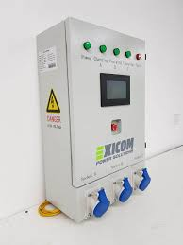 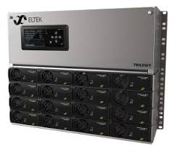

**2.9.8 QA/Testing Services**

Dynamic business needs mandate superior performance of your IT systems. Your applications need to be secured and user-friendly, while also responding faster and complying with prevailing regulations. Quality assurance (QA) and testing are extremely crucial in the software development cycle and should be introduced at the earliest stage of the project. Telematics holds industry best dedicated Quality Assurance Resources and a wide range of comprehensive testing methods and tools to deliver only the highest quality solutions. Telematics QA specialists are SEI CMMI certified expert in multiple technologies, platforms and standards.

Telematics Quality Assurance and Testing services focused areas are:

* Functional and Regression Testing
* GUI and Usability Testing
* Accessibility Testing
* Compatibility Testing
* Performance Testing
* Installation/Configuration Testing
* System/Integration Testing
* Security Testing
* Internationalization/Localization Testing
* User Acceptance Testing (UAT)

**2.9.9 QA / Testing Consultancy**

* Full Lifecycle Process Improvement
* QA Process Consulting
* Test Strategy Elaboration and Management

**2.9.10 Life at Telematics**

Telematics looks for the right talents to meet business needs and to create homely as well as a professional environment that allows them to work at their best. Telematics believes to be an employee driven company who are innovative, free-thinking, diverse, proactive, and in need of a challenge.

**2.9.11 Telematics’s Popular Clients**

** **

**nortel.png** DELOITTE.png

  airtel.jpg

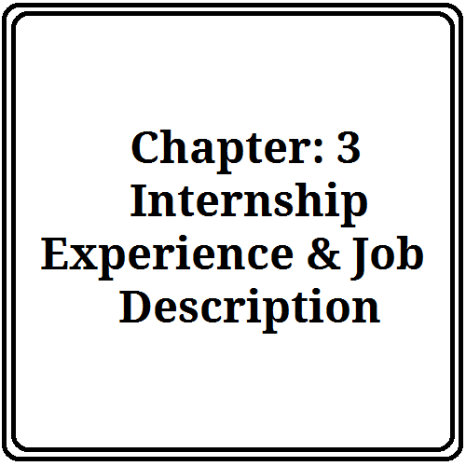

**3.1 Software development process of Telematics**

A software development process, also known as a software development life-cycle (SDLC), is a structure imposed on the development of a software product. Similar terms include software life cycle and software process. It is often considered a subset of systems development life cycle. There are several models for such processes, each describing approaches to a variety of tasks or activities that take place during the process. Some people consider a life-cycle model a more general term and a software development process a more specific term. For example, there are many specific software development processes that 'fit' the spiral life-cycle model. ISO/IEC 12207 is an international standard for software life-cycle processes. It aims to be the standard that defines all the tasks required for developing and maintaining software.

The international standard for describing the method of selecting, implementing and monitoring the life cycle for software is ISO/IEC 12207.

**3.2 Software development activities:**

**3.2.1 Planning:**

Planning is an objective of each and every activity, where we want to discover things that belong to the project. An important task in creating a software program is extracting the requirements or requirements analysis. Customers typically have an abstract idea of what they want as an end result, but do not know what software should do. Skilled and experienced software engineers recognize incomplete, ambiguous, or even contradictory requirements at this point. Frequently demonstrating live code may help reduce the risk that the requirements are incorrect.

Once the general requirements are gathered from the client, an analysis of the scope of the development should be determined and clearly stated.

**3.2.2 Implementation, testing and documenting:**

Implementation is the part of the process where software engineers actually program the code for the project. Software testing is an integral and important phase of the software development process. This part of the process ensures that defects are recognized as soon as possible.

Documenting the internal design of software for the purpose of future maintenance and enhancement is done throughout development. This may also include the writing of an API, be it external or internal. The software engineering process chosen by the developing team will determine how much internal documentation (if any) is necessary. Plan-driven models (e.g. Waterfall) generally produce more documentation than agile models.

**3.2.3 Deployment and maintenance:**

Deployment starts directly after the code is appropriately tested, approved for release, and sold or otherwise distributed into a production environment. This may involve installation, customization (such as by setting parameters to the customer's values), testing, and possibly an extended period of evaluation. Software training and support is important, as software is only effective if it is used correctly.

Maintaining and enhancing software to cope with newly discovered faults or requirements can take substantial time and effort, as missed requirements may force redesign of the software.

**3.3 Software development models:**

Several models exist to streamline the development process. Each one has its pros and cons, and it is up to the development team to adopt the most appropriate one for the project. Sometimes a combination of the models may be more suitable.

**3.3.1 Waterfall model:**

The activities of the software development process represented in the waterfall model. There are several other models to represent this process.

The waterfall model shows a process, where developers are to follow these phases in order:

1. Requirements specification (Requirements analysis)

2. Software design

3. Implementation and Integration

4. Testing (or Validation)

5. Deployment (or Installation)

6. Maintenance

In a strict Waterfall model, after each phase is finished, it proceeds to the next one. Reviews may occur before moving to the next phase which allows for the possibility of changes (which may involve a formal change control process).

Reviews may also be employed to ensure that the phase is indeed complete; the phase completion criteria are often referred to as a "gate" that the project must pass through to move to the next phase. Waterfall discourages revisiting and revising any prior phase once it's complete. This "inflexibility" in a pure Waterfall model has been a source of criticism by supporters of other more "flexible" models.

**3.3.2 Code and fix**

"Code and fix" development is not so much a deliberate strategy as an artifact of naïveté and schedule pressure on software developers. Without much of a design in the way, programmers immediately begin producing code. At some point, testing begins (often late in the development cycle), and the unavoidable bugs must then be fixed before the product can be shipped. See also: Continuous integration and Cowboy coding.

**3.4 Process improvement models:**

**3.4.1 Capability Maturity Model Integration**

The Capability Maturity Model Integration (CMMI) is one of the leading models and based on best practice. Independent assessments grade organizations on how well they follow their defined processes, not on the quality of those processes or the software produced. CMMI has replaced CMM.

**3.4.2 ISO 9000**

ISO 9000 describes standards for a formally organized process to manufacture a product and the methods of managing and monitoring progress. Although the standard was originally created for the manufacturing sector, ISO 9000 standards have been applied to software development as well. Like CMMI, certification with ISO 9000 does not guarantee the quality of the end result, only that formalized business processes have been followed.

**3.5 Formal methods:**

Formal methods are mathematical approaches to solving software (and hardware) problems at the requirements, specification, and design levels. Formal methods are most likely to be applied to safety-critical or security-critical software and systems, such as avionics software. Software safety assurance standards, such as DO-178B, DO-178C, and Criteria demand formal methods at the highest levels of categorization.

**3.5.1 Types of Team in a Software Firm**

1. Requirement analysis team

2. Planning team

3. Designing team

4. Coders team

5. Database team

6. Testing team

**3.5.2 Hierarchy of a Software Development Firm**

level 4 - Associate / assistant Software Engineer (basically a trainee) duration to go to next tier (1 to 1.5Yrs) Software engineer - next to ASE (1.5 Yrs.)

Level 3 - Senior Software Engineer (1.5 Yrs.)

Level 2 -Team lead, Technical lead (2-3 Yrs.)

Level 1 - Project Manager (3-5 Yrs.)

level 0 – Senior Project Manager , location manager, account manager, resource manager, delivery manager

**3.5.3 Overview of Scrum:**

Scrum is a lightweight agile method for software development. Scrum is named after the Scrum in rugby, which is a way to restart the game after an accidental infringement. This entry describes the software development part of Scrum.

Scrum was first applied in 1993 at Easel Corporation by Jeff Sutherland, John Scumniotales and Jeff McKenna when building an object-oriented design and analysis (OOAD) tool incorporating Round-trip engineering. At that time they needed a development method that had rapid application development and where product requirements could easily be translated into working code. These principles later became some of the basics of Scrum.

**Characteristics:**

Scrum assumes that the software development process is complicated and unpredictable and treats it as a controlled black box instead of a theoretical, fully-defined process. This is one of the biggest differences between Scrum and the Waterfall and Spiral methodologies, which view the software development process as a fully defined process. Most problems encountered when using these older, formal types of methodologies are:

* Requirements are not fully understood at the beginning of the process
* Requirements change during the process.
* The process becomes unpredictable when new tools and technologies are used

To manage these processes with flexibility, Scrum supplies techniques and controls to manage this unpredictable process

**Development Phase Techniques:**

**Team creation**

Scrum believes that a development team should perform as a sport team, every team member working independently but towards the same goal. Scrum suggests that a team has a maximum of 6 - 7 members. The team facilitator is called the Scrum master. His/her job is to implement and manage the Scrum process in the project. The Scrum team as a whole defines the practices, meetings, artifact and terminology of SCRUM for the team and the Scrum Master ensures adherence to these "norms" identified. Scrum masters serve a facilitator role and their authority is mostly indirect. Scrum masters focus most of their time in managing outside interference for the Scrum team and solving outside impediments or ‘Blockers’ that cannot be solved by the Scrum team. The master also focuses on ensuring transparency into the development process by maintaining the multiple Scrum artifacts defined elsewhere in this article.

**3.5.4 Backlog creation**

**There are 3 types of backlogs:**

1. Product - Acts as a repository for requirements targeted for release at some point. These are typically high level requirements with high level estimates provided by the product stakeholders.
2. Release - Requirements pulled from the product backlog and identified and prioritized for an upcoming release. The release backlog contains more details about the requirement and low level estimate which are usually estimated by the team performing the work.
3. Sprint - At the beginning of each sprint, the team has sprint planning with an end result being a backlog of requirements/sub-requirements that the team anticipates completing at the end of the sprint. By completing, that means fully coded, tested and documented. These are the items that the team will "Burndown" against throughout the duration of the sprint.

**Project segmentation**

The whole project gets divided into periods of time with a maximum duration of 4 weeks. One period is called a Sprint and every team gets a backlog to execute within the given Sprint.

**Scrum meetings**

* During the sprint, the team conducts daily scrum meetings.
* The meetings are held in the same place at the same time every work day.
* The meetings don’t last for more than 30 minutes.
* A scrum master is appointed.

The scrum master is responsible for asking every team member the following three questions:

1. What have you done since the last scrum meeting?

2. What has impeded your work?

3. What do you plan on doing between now and the next scrum meeting?

**3.5.5 The Agile**

Along with the rest of the software industry Telematics uses agile method for the development cycle. Here a detail of agile is described. Overview The literal meaning of the word agile, an adjective, is “Characterized by quickness, lightness, and ease of movement.” So this indicates that Agile Software development is about fast delivery of software with more ease of development. Classically, “Agile software development is a style of software development that emphasizes customer satisfaction through continuous delivery of functional software”.

**Why Agile:** **Benefits to the Customer**

1. Customer is more actively involved, and gets higher priority

2. He gets to know regular and frequent status of the application

3. Requirements are accepted after each iteration

4. Since the methodology emphasizes rapid delivery, time-to-market is less. So the key functionalities can be available to use sooner.

5. Delivery is defined by fixed timescale. So customer is assured of receiving some functionality by a fixed time period.

6. More Testing is done, so better software quality is delivered

**3.5.6 How Telematics supports agile software development:**

The fast-paced development and cross-silo coordination necessary for a successful agile project require organizations to visualize the scope of the project and the project schedule, orchestrate the integration and testing process, and enforce adherence to agile processes. Visualization helps development organizations to understand the project schedule and see the scope both of the entire project and of each iteration within the project. Telematics management helps teams visualize the available resources to make sure they have the time, money, and personnel to complete the project. Additionally, Mariner helps teams organize iteration or sprint plans to manage and schedule software releases. Telematics Team also helps teams stay aware of the scope of an agile project by keeping track of user stories within XP, managing project and sprint backlogs within Scrum, or tracking tasks for other methodologies.

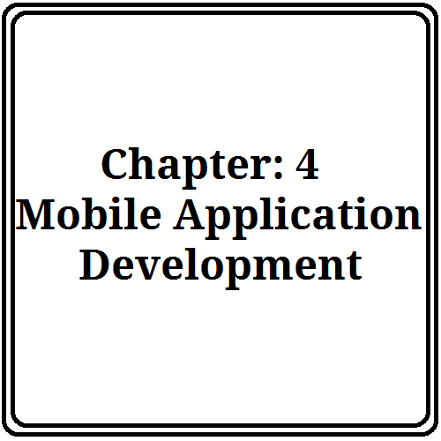

**4.1 Overview**

Mobile application development is the process by which application software is developed for low-power handheld devices, such as personal digital assistants, enterprise digital assistants or mobile phones. These applications can be pre-installed on phones during manufacturing, downloaded by customers from various mobile software distribution platforms, or delivered as web applications using server-side or client-side processing (e.g. JavaScript) to provide an "application-like" experience within a Web browser. Application software developers also have to consider a lengthy array of screen sizes, hardware specifications and configurations because of intense competition in mobile software and changes within each of the platforms. Mobile app development has been steadily growing, both in terms of revenues and jobs created. A 2013 analyst report estimates there are 529,000 direct App Economy jobs within the EU 28 members, 60% of which are mobile app developers.

**4.2 Steps of development**

1. Select an exclusive niche for your app. Decide exactly what you want your app to do and how you should present it before your future audience. See to it that your chosen niche is popular, but not too saturated.

2. Check out all similar apps in other app stores. Look up their popularity quotient by studying their download statistics, or by looking into their ratings and reviews. Also try to find out how they manage to strike that special chord with users.

a. 5 of the Best Third-Party Mobile Cloud Sync Providers

3. If possible, try downloading similar apps, to know about their pros and cons and also to see what makes them tick, from an end-user perspective. Though you may have to spend on some of these apps, it will give you a fair idea about the competition.

4. See that your app offers something that extra something special to your users. This will let your app stand out from the rest.

b. How to Engage the User with Your Mobile App

5. Be minimalistic with the app’s features initially. Try not to cram too many things into your first release – more advanced features can be added onto your future releases.

6. Initially, develop mobile software for only one mobile platform. Do not rush to deliver the same to multiple mobile platforms unless you are absolutely sure where you are going with your app. Make sure to plan ahead and choose the right mobile platform for your app.

c. How to Choose the Right Mobile Platform for App Development

7. If possible, make detailed UI sketches of all app screens, instead of merely writing them down. This will make it easier for you and also give the app a better finish.

8. Develop your app in-house if you can. This saves you a lot of time and money. Else, be very particular about the person or company you hire to develop your app for you. Be actively involved in every stage of the app development and test it thoroughly before submitting it to the marketplace.

d. Hire a Professional Developer to Create Apple iPhone Apps

9. Look into the nitty-gritty’s of the mobile app market you would like to target. Understand the app market’s specifications and stipulations, so that you minimize the chances of rejection to that extent.

10. Set the right keyword and description for your app. This is an important aspect of app submission and may also help minimize your own app promotion efforts in the app store.

11. It is also important that you set the right price for your app. Study the pricing of similar apps in the market and price your app competitively, at par with them. Ideally, offer users a free trial edition of your app. This will let you gauge the public response to your app, without immediately inviting criticism from end-users.

e. How to Price Your Mobile Application

12. Take your customers seriously. Listen closely to what they have to say via their feedback and app ratings. This will give you pointers on how to proceed with later versions of your app as well.

**4.3 Tips:**

1. Talk to your friends about the app you have in mind. They will be able to give you a third-person perspective on the same.

2. Setup a clear schedule and deadline for the release of your app. Stick to that schedule, so that you do not delay the whole process by procrastinating.

3. Ask friends to test your app before actually submitting to the marketplace. After app submission, ask them to rate and review the software – that will make it look like you already have customers.

4. Take time out for app marketing and promotion. Create a website for your app and upload photos and videos of the same online. In short, try to give your app the maximum possible exposure.

5. Keep your entire focus on the end-user. Remember, they are the reason why you are developing the mobile software in the first place!

**Popular Mobile Application Platforms:**

* Android
* Windows
* Phone
* iPhone
* Java Featured Phone
* Symbian

**Apps developed by Telematics under name GrapeBits in Play Store :**

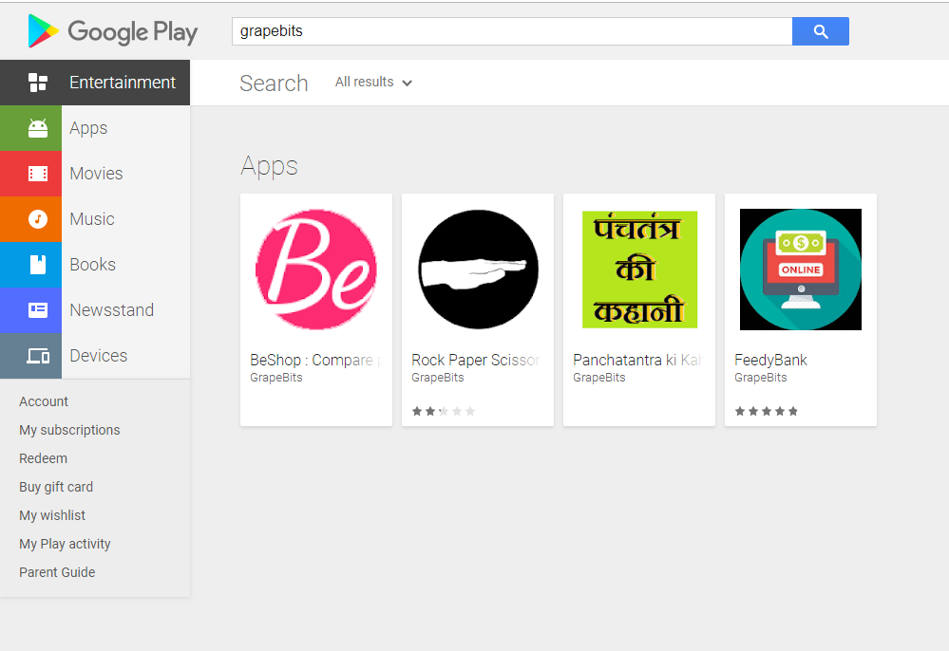

**4.4 Motivation for Android**

Android, the world's most popular mobile platform Android powers hundreds of millions of mobile devices in more than 190 countries around the world. It's the largest installed base of any mobile platform and growing fast—every day another million users power up their Android devices for the first time and start looking for apps, games, and other digital content.

Android gives you a world-class platform for creating apps and games for Android users everywhere, as well as an open marketplace for distributing to them instantly.

* Building on the contributions of the open-source Linux community and more than 300 hardware, software, and carrier partners, Android has rapidly become the fastest-growing mobile OS.
* Every day more than 1 million new Android devices are activated worldwide.
* Android users download more than 1.5 billion apps and games from Google Play each month.
* For developers, Android innovation lets you build powerful, differentiated applications that use the latest mobile technologies.
* Powerful development framework
* Open marketplace for distributing your apps

**4.5 Android Application Development**

Applications are usually developed in the Java programming language using the Android Software Development Kit, but other development tools are available. As of October 2012, more than 700,000 applications have been developed for Android, with over 25 billion downloads. A June 2011 research indicated that over 67% of mobile developers used the platform, at the time of publication. In Q2 2012; around 105 million units of Android smartphones were shipped which acquires a total share of 68% in overall smartphones sale till 2012.

**Initially for android development we need:**

* Android Studio.
* Download the latest SDK tools and platforms using the SDK Manager.

**We have used the following tools suggested from DataSoft as they use those:**

* Eclipse IDE
* Android SDK 19



**5.1 Applications**

I developed two android apps through this time of industrial training. The application names are:

* Panchatantra Ki Kahani
* BeShop : Compare prices and products

I also developed an Integrated Development Environment for C language through this time of industrial training. The IDE name is: ***Dragme IDE***

**5.2 Panchatantra Ki Kahani**

This mobile app is collection of Panchatantra tells. The Panchatantra is a collection of Sanskrit fables in prose and verse. The original version, now lost, was written around 200 BC and is attributed to

Vishnu Sarma.  
Link:**https://play.google.com/store/apps/details?id=cf.grapebits.panchtantrkikahani**

The Panchatantra reached its current form in the 4th-6th centuries AD. One of the most influential Sanskrit contributions to world literature, it was exported to China and South East Asia by Buddhist Monks on Pilgrimage. During KhosrauI of Persia era, his famous minister Burzoe translated Indian Panchatantra from Sanskrit into middle Persian language of Pahlavi and called it Kelileh va Demneh.

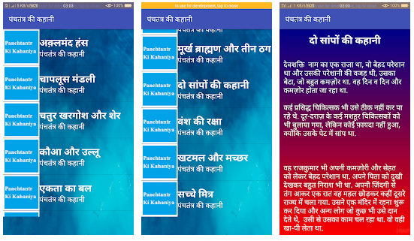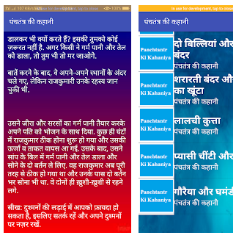

**5.3 BeShop: Compare prices and products**

****BeShop is the smart shopping assistant that helps you Compare Prices, products and Offers from all top 100+ online stores.

Link: **https://play.google.com/store/apps/details?id=cf.grapebits.beshop**

**Features:**

* Compare Prices

Compare prices from 100+ online shopping stores on over 10 million products. BeShop always finds you the best price on all categories including Mobile Phones, Grocery, Home products, Daily use Products Laptops, Cloth, Cameras, TVs, Fashion, Home Decor and any other products etc!

* Low Battery and Data Usage

The app is optimized to make it the lightest and fastest shopping app in India

* Instant Price Alerts

Get instant alerts when price drops for a product that you are tracking! We make sure you always get great deals and offers!

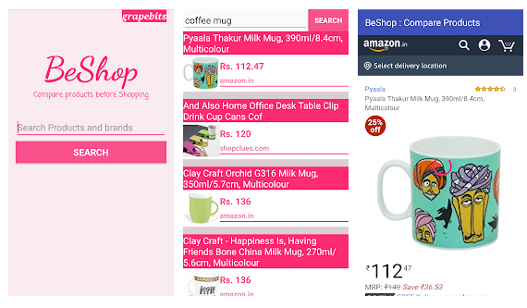

**5.4 Dragme IDE: Visual IDE for C language**

# big icon.pngDragme IDE

Dragme IDE is a visual-based integrated development environment (IDE) and a child-friendly computer environment that can help computer learner and professionals to create various programs in C languages by using blocks, visual elements that can be easily dragged and dropped on the screen, and also modified according to their needs. It has Codeground that helps professional programmers to create various programs by entering source code in it. Developed by Indian Programmer Harsh Mishra at the GrapeBits through Internship period, the integrated development environment (IDE) is designed to help children (ages 8 and up) learn to utilize their imaginations and programming skill, practice common sense, and, most importantly, to interact with computers and learn computer programming.

It is influenced by Scratch and Snap!.

**Origin of name**

Drag and Drop is a technique used by computer users in GUI (example: windows, mac os) to performs operation like movement of files or icons in unique ways. It uses blocks, visual elements that can be easily dragged and dropped on the screen, and also modified according to needs, to create C programs and their source code. Therefore, It is named as Dragme IDE.

**Applications**

Dragme IDE has been used globally for educational and commercial use. It is used in many different industries to both learn and develop software.

**User interface**

It starts in a splash-screen-like manner that lets user start the IDE, then open it in browser or exit the app altogether. It is worth noting that you need to have Java Runtime Environment installed on the computer in order for this IDE to run properly. The Playground main screen is divided into five categories: "Blocks," "Code," "Load", "Help" and "Code-ground". The "Blocks" section lets us access a collection of blocks that we can develop applications with. The category names are Control, Input/output, Logic, Loops, Math, Variables and Text, and are rather intuitive for experienced programmers.The Codeground main screen contains three categories: "Playground", "Clear" and "Run".

**Educational Use**

Student can access the "Code" section of the application and observe how the blocks he add to his project influence the end product. More so, it is possible to choose from a bunch of sample applications by opening the "Load" menu and choosing his favorite one from the list.

**Direct Download:**

<http://www.softpedia.com/get/Programming/Coding-languages-Compilers/Dragme-IDE.shtml>

<https://www.freewarefiles.com/Dragme-IDE-for-C-Language-_program_112391.html>

<http://dragme.sourceforge.io/>

**\*No of downloads in 1st month: 2,000**

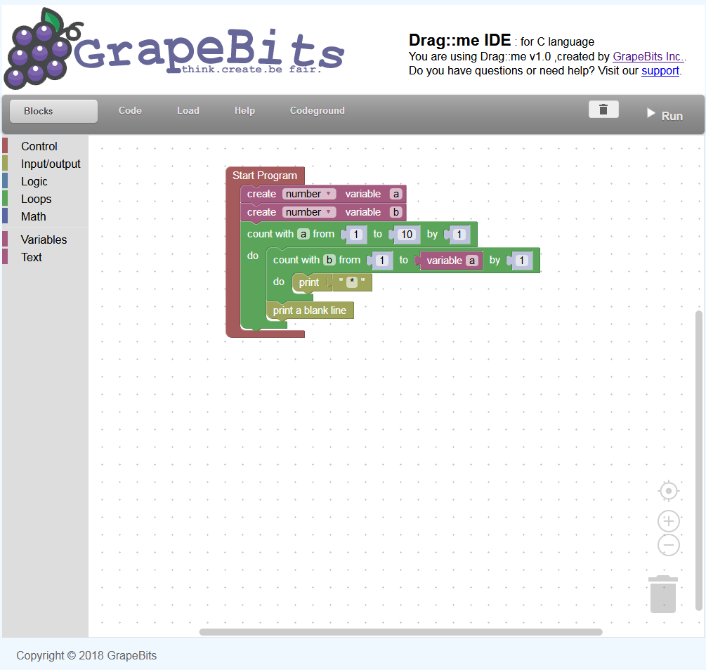

**Fig: Dragme IDE Playground**



**6.1 Marketing & Marketing Details.**

In the face of increased competition for attention on digital channels, technology companies in the B2B sector struggle to reach the right decision makers on the right channels to increase their sales funnel. The ability to connect with these decision makers about an important issue, goal or challenge to their business can have a dramatic impact on the success of most any enterprise technology organization.

To maximize their investment in marketing initiatives, organizations look for strategies and tools that have the most potential to engage decision makers by proving that they understand what challenges their target industry faces, that they’re a thought leader and have a unique solution that can provide substantial ROI.

Here are some key marketing strategies that enterprise tech companies can use to transform how they market themselves.

#### Create Animated Infographics

#### Create Animated Explainers.

#### Client Testimonials.

* Quality products

**6.2 Man Power & its Management**

Manpower planning also known as Human Resource Planning (H.R.P.) is the starting point in staffing function. HR planning basically deals with forecasting of human resources needed in an organization/ enterprise in future though there is not complete agreement among writers and practitioners on the exact scope of HR planning function

On the basis of the review of HRP Geisler has emphasised that a suitable definition of HRP should include four aspects—forecasting manpower requirements, developing appropriate policies and programmes for meeting these requirements, implementing policies and programmes and controlling these programmes.

(i) Forecasting future manpower needs.

(ii) Inventorying present manpower resources and analysing the degree to which these resources are employed optimally.

(iii) Perceiving manpower problem by projecting present resources into the future and comparing with the forecast of requirements to find out their adequacy, both quantitatively and qualitatively.

(iv) Planning the necessary programmes of recruitment, selection training, deployment, utilisation, transfer, promotion, demotion, development, motivation and compensation.

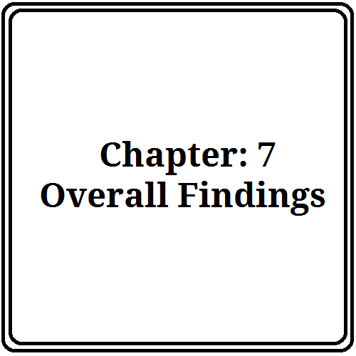

**7.1 Future of the firm in India:**

They have come a long way since then and learned a lot about making software. The Waterfall Model is now considered a flawed method because it is so rigid and unrealistic. In the real world, software projects have ill-defined and constantly evolving requirements, making it impossible to think everything through at once. Instead, the best software today is created and evolved using agile methods. These techniques allow engineers to continuously re-align software with business and customer needs.

With the advent of modern programming languages (Java, PHP, Python, .NET and Ruby), rich libraries, and unprecedented infrastructure services, we are arriving at yet another evolutionary step. To build software today all you need is a few good men (or women!). In this post we trace how we got here and where we are heading next.

They have some future plans. They are as follow: To make the country dynamic they have many projects for which they will work in the future. And they have also future plans for their firm. Such as:

**Advanced Collaboration Environments and Scientific Workplaces of the Future:** **Suggested productivity gains:**

* 2x-10x depending on task
* Higher quality output
* Fewer changes overtime
* Better and faster decisions

**Radical Collection Recently used to:**

* Annotate new genome data at the firm
* Design various mission in the world
* Evaluate fusion reactor designs.

**7.2 Current position and Prospective future of Telematics in India:**

Telematics wants to take our country a long way through development of new software and technologies. They are always up to date with the new technology emerging every day. We have seen their GrapeBits App team is very enthusiastic concentrating on developing mobile apps. Their plans are:

* Generating new ideas
* Developing user friendly apps
* Building their own app market

**7.3 Recommendation:**

There is a lot of possibility in the software industry for India. A lot of fresh graduate are joining and the industry is becoming very powerful day by day. The talented young generation can take the industry a long way. We are already developing the software for us and exporting abroad. Through outsourcing and freelancing a lot of young people are getting their own wages. The new firms can be formed to improve the industry. But there are many obstacles too. As a developing first world country we face a lot of unwanted conditions in the way. We have to overcome those and have to make the software industry one of most powerful in the world. Our suggestions are:

* The government should proper steps to make the way for new start-up.
* Young people should form their own firm.
* Business magnets should invest more in this sector.
* The ICT act should be more flexible for the developers.
* The business rules should be easier for software industry.

**7.4 Conclusion:**

The total period while we were visiting Telematics Service Systems was very pleasant to us. It will help us a lot in future life. Without the practical knowledge it is quite impossible to develop quality software. This industrial tour has paved the way to look into the development environment and marketplace. The market does not depend on only developing quality application. It is a lot more things than those. First we have to specify what we have to develop, for whom, why and how. Understanding the user’s mind and their requirements a software engineer has to think about new software. They gave a lot of good advice that we will take with us as we prepare to enter the workforce after graduation.

The age is totally dependent on modern information technologies. Nobody can escape away from it. Our one step to invent new technology can take the whole world a step forward.